

Table of Contents

Chapter 1 Introduction 3

Chapter 2 Installation and Configuration 4

2.1 Installation 5

2.2 Configuration 6

2.3 Administrator Notes 8

2.4 Developer Notes 9

# Introduction

Sitecore Workflow Escalator is a shared source module for Sitecore CMS 6.x. It allows to notify persons by email when content item(s) remain(s) in the non-final workflow state for more than the specified time interval.

It also provides a validator in the Content Editor. A warning message appears when a user navigates to an item that exceeded the pre-set time interval. A validator message will appear to a user who is subscribed as a recipient for such messages and has appropriate security rights for the corresponding workflow state.

# Installation and Configuration

The Installation and Configuration chapter contains the following sections:

* Installation
* Configuration
* Administrator Notes
* Developer Notes

## Installation

The Sitecore Workflow Escalator module is distributed as a standard package. It installs the module itself as well as a custom AccountSelector field, that is required for module’s correct behavior.

Items installed with the package:

1. Master database

* /Sitecore/Templates/Workflow Escalator Module/Escalator State
* /Sitecore /Templates/Workflow Escalator Module/Workflow escalator e-mail settings
* /Sitecore/System/Tasks/Commands/Notify
* /Sitecore/System/Tasks/Schedules/Workflow Escalator Task
* /Sitecore/System/Modules/Workflow Escalator

1. Core database

* /Sitecore/System/Dictionary/W/WarningEscalatorText
* /Sitecore/System/Dictionary/W/WarningEscalatorTitle
* /Sitecore/System/Fie d types/Developer Types/AccountSelector
* /Sitecore/System/Field types/Developer Types/AccountSelector/Menu/Assign
* /Sitecore/System/Field types/Developer Types/AccountSelector/Menu/Clear

Files installed with the package:

* + Bin\ CustomFields.AccountSelector.dll
  + Bin\ Sitecore.Modules.WorkflowEscalator.dll
  + App_Config\Include\worflowescalator.config
  + App_Config\Include\accountselector.config
  + Sitecore\shell\Applications\Security\AccountSelector\AccountSelector.css
  + Sitecore\shell\Applications\Security\AccountSelector\AccountSelector.js
  + Sitecore\shell\Applications\Security\AccountSelector\AccountSelector.xaml
  + Sitecore\shell\Applications\Security\SelectAccount\SelectAccount.xaml

## Configuration

After installation you should proceed with the following to fine-tune your Workflow Escalator Module:

1. Configure email settings under /Sitecore/System/Modules/Workflow Escalator

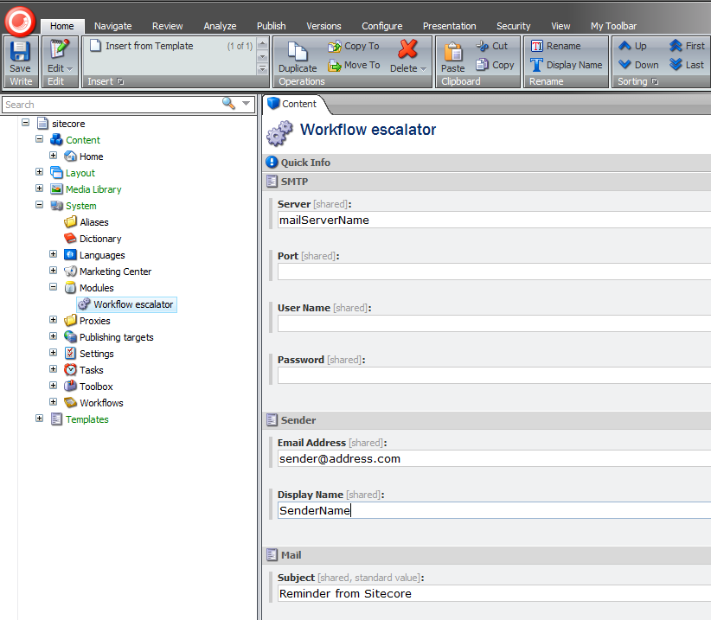

You can set the following fields:

* Server – mail server name (if not specified, a "MailServer" setting from web.config will be used)
* Port – mail server port number
* User Name - mail server user (if SMTP requires login)
* Password - mail server password (if SMTP requires login)
* Email address - sender e-mail address (if not specified, an EmailReminder.FromAddress” setting from web.config will be used)
* Display Name - sender display name
* Subject – mail subject (if not specified, a "Tasks.EmailReminderSubject" setting from web.config will be used)
* Item description – item specific text pattern (if not specified, a "Tasks.EmailReminderText" setting from web.config will be used). Is used for formatting each item notification when rendering an email to specific person. Available replaceable tokens:{itempath}(item’s path), {version}(item’s version), {language}(item’s language).
* Header – email header text
* Footer – email footer pattern. Available replaceable tokens:{sender}( sender name specified in Display Name field).

1. Create the desired workflow state(s) based on /Sitecore/ Templates/Workflow Escalator Module/Escalator State template.

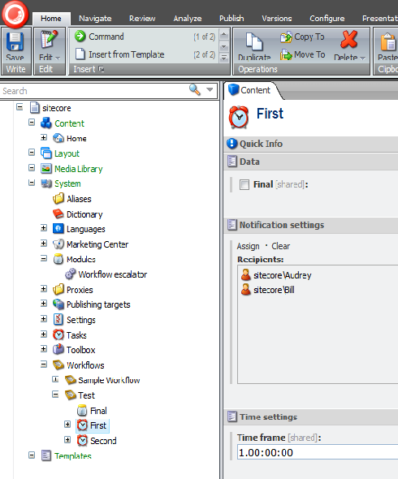

Escalator state template introduces two additional fields:

* Recipients – a list of user(s) and(or) role(s) who will receive notification emails. Custom AccountSelector field is used to populate the list**.**

Note

Please ensure that user(s) and(or) role(s) in the list are provided with appropriate security rights allowing them to edit content in the workflow state.

* Time frame – time limit for content’s staying in the workflow state. If the limit is exceeded, notification email(s) will be sent to specified recipient(s). The default value is one day. The supported format: d.HH:MM:SS

1. Configure the schedule for Workflow Escalator task under /Sitecore/System/Tasks/Schedules/Workflow Escalator Task.

For any scheduled task the frequency of execution depends on the settings per task and the general settings in web.config. A task resides in the Master database.

## Administrator Notes

The Content Editor warning text and title can be changed by modifying the Phrase field of /Sitecore/System/Dictionary/W/WarningEscalatorText and /Sitecore/System/Dictionary/W/WarningEscalatorTitle items accordingly.

## Developer Notes

The notification email rendering can easily be modified. To do this:

* + Create a class implementing Sitecore.Modules.WorkflowEscalator.IMailConfigurator interface
  + Assign MailConfigurator property of Sitecore.Modules.WorkflowEscalator.EmailUtility class